**WEEK 2 : MOCKITO ADVANCED EXERCISES**

**SUPERSET ID : 6386707**

**Exercise 1 :**

**Repository interface**

public interface Repository {

String getData();

}

**Service.java**

public class Service {

private final Repository repository;

public Service(Repository repository) {

this.repository = repository;

}

public String processData() {

String data = repository.getData();

return "Processed " + data;

}

}

**ServiceTest.java**

import static org.mockito.Mockito.*;

import org.junit.jupiter.api.Test;

import static org.junit.jupiter.api.Assertions.*;

public class ServiceTest {

@Test

public void testServiceWithMockRepository() {

Repository mockRepository = mock(Repository.class);

when(mockRepository.getData()).thenReturn("Mock Data");

Service service = new Service(mockRepository);

String result = service.processData();

assertEquals("Processed Mock Data", result);

}

}

**OUTPUT**

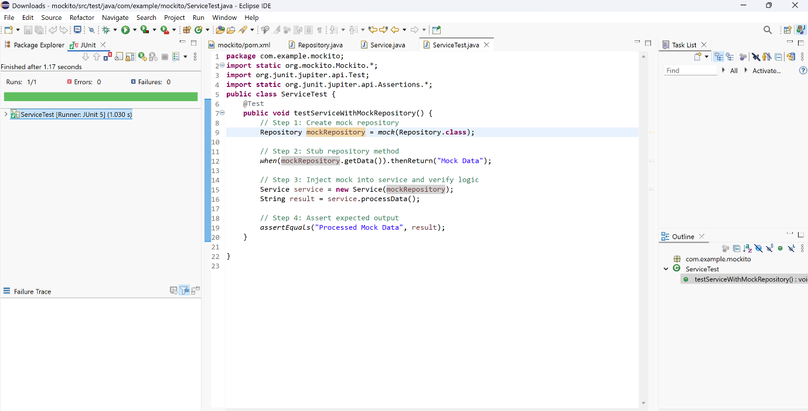

**Exercise 2 :**

**RestClient Interface**

public interface RestClient {

String getResponse();

}

**ApiService.java**

public class ApiService {

private final RestClient restClient;

public ApiService(RestClient restClient) {

this.restClient = restClient;

}

public String fetchData() {

String response = restClient.getResponse();

return "Fetched " + response;

}

}

**ApiServiceTest.java**

import static org.mockito.Mockito.*;

import org.junit.jupiter.api.Test;

import static org.junit.jupiter.api.Assertions.*;

public class ApiServiceTest {

@Test

public void testServiceWithMockRestClient() {

RestClient mockRestClient = mock(RestClient.class);

when(mockRestClient.getResponse()).thenReturn("Mock Response");

ApiService apiService = new ApiService(mockRestClient);

String result = apiService.fetchData();

assertEquals("Fetched Mock Response", result);

}

}

**OUTPUT**

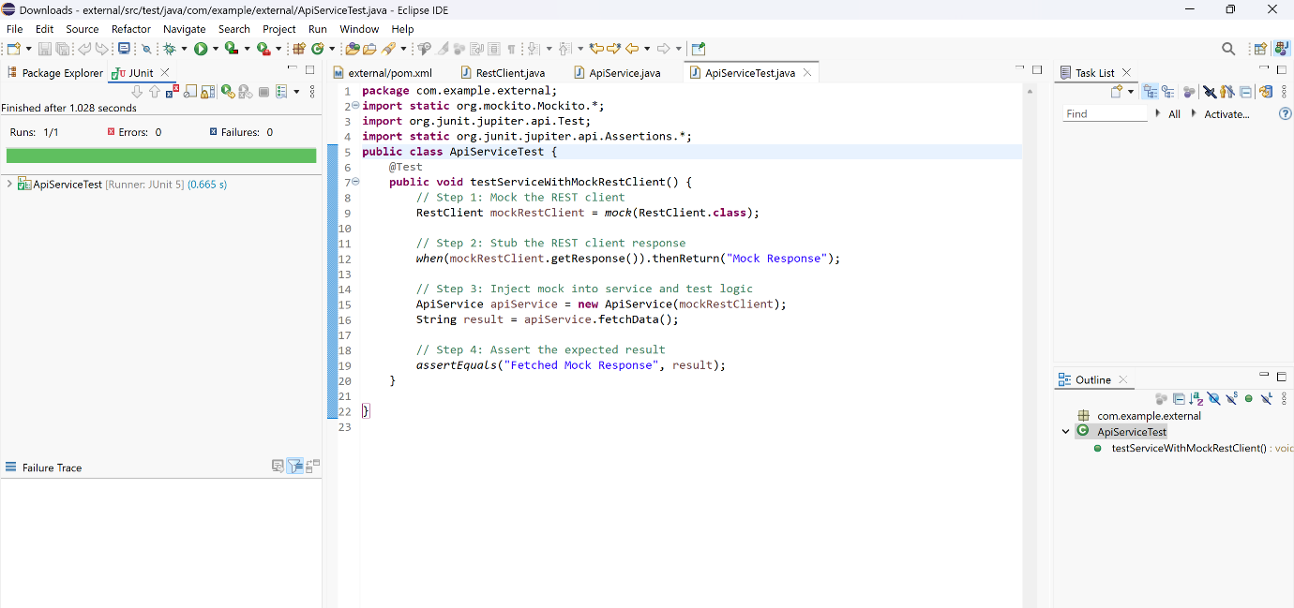

**Exercise 3 : Mocking File I/O**

**FileReader Interface**

public interface FileReader {

String read();

}

**FileWriter Interface**

public interface FileWriter {

void write(String content);

}

**FileService.java**

public class FileService {

private final FileReader fileReader;

private final FileWriter fileWriter;

public FileService(FileReader fileReader, FileWriter fileWriter) {

this.fileReader = fileReader;

this.fileWriter = fileWriter;

}

public String processFile() {

String content = fileReader.read();

String processedContent = "Processed " + content;

fileWriter.write(processedContent);

return processedContent;

}

}

**FileServiceTest.java**

import static org.mockito.Mockito.*;

import org.junit.jupiter.api.Test;

import static org.junit.jupiter.api.Assertions.*;

public class FileServiceTest {

@Test

public void testServiceWithMockFileIO() {

FileReader mockFileReader = mock(FileReader.class);

FileWriter mockFileWriter = mock(FileWriter.class);

when(mockFileReader.read()).thenReturn("Mock File Content");

FileService fileService = new FileService(mockFileReader, mockFileWriter);

String result = fileService.processFile();

assertEquals("Processed Mock File Content", result);

verify(mockFileWriter).write("Processed Mock File Content");

}

}

**OUTPUT**

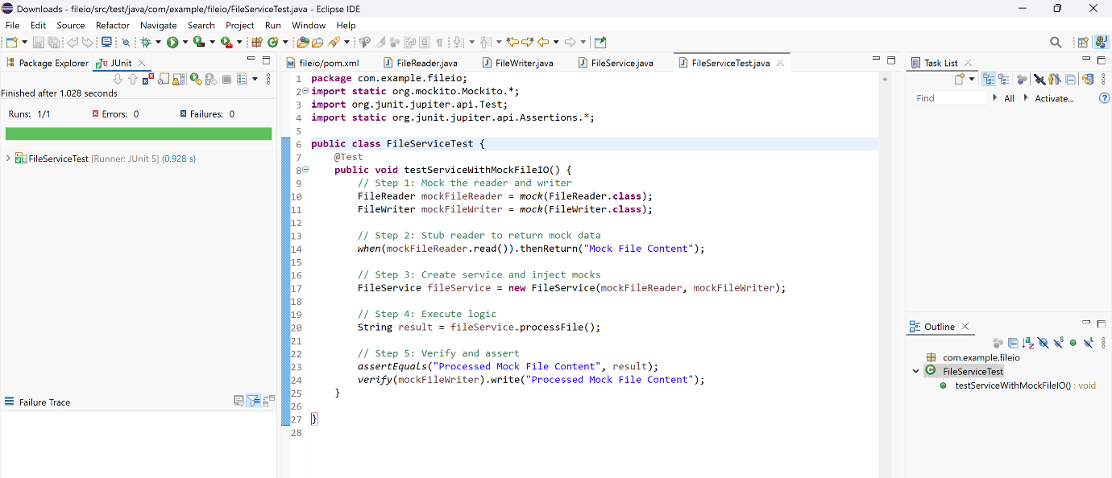

**Exercise 4 : Mocking Network Interactions**

**NetworkClient Interface**

public interface NetworkClient {

String connect();

}

**NetworkService.java**

public class NetworkService {

private final NetworkClient networkClient;

public NetworkService(NetworkClient networkClient) {

this.networkClient = networkClient;

}

public String connectToServer() {

String connection = networkClient.connect();

return "Connected to " + connection;

}

}

**NetworkServiceTest.java**

import static org.mockito.Mockito.*;

import org.junit.jupiter.api.Test;

import static org.junit.jupiter.api.Assertions.*;

public class NetworkServiceTest {

@Test

public void testServiceWithMockNetworkClient() {

NetworkClient mockNetworkClient = mock(NetworkClient.class);

when(mockNetworkClient.connect()).thenReturn("Mock Connection");

NetworkService networkService = new NetworkService(mockNetworkClient);

String result = networkService.connectToServer();

assertEquals("Connected to Mock Connection", result);

}

}

**OUTPUT**

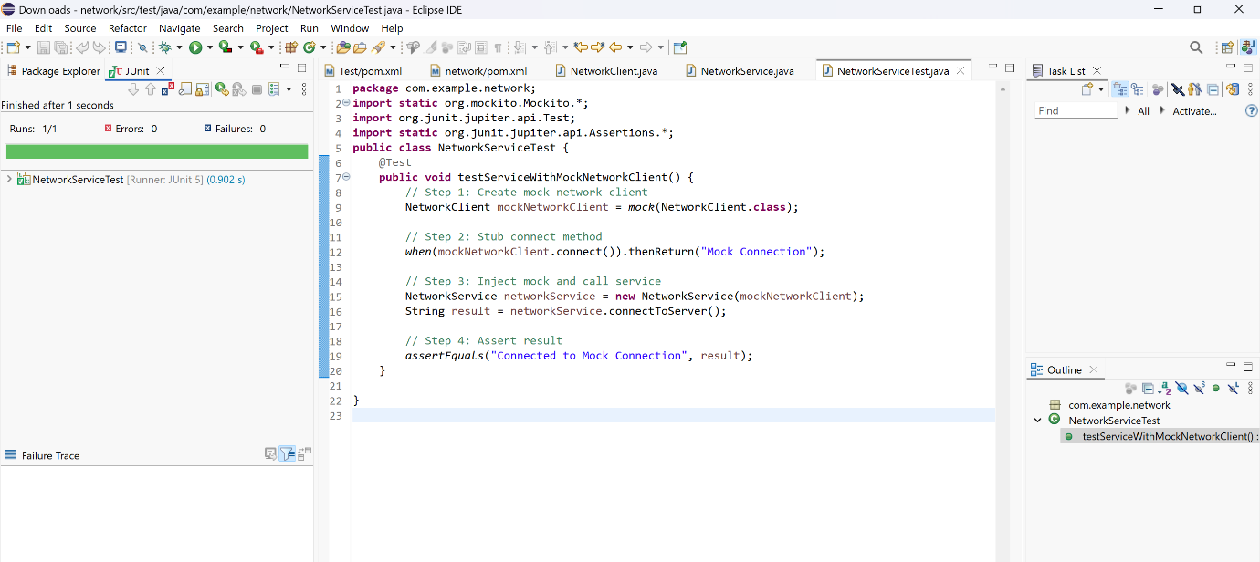

**Exercise 5 : Mocking Multiple Return Values**

**Repository Interface**

public interface Repository {

String getData();

}

**Service Class**

public class Service {

private final Repository repository;

public Service(Repository repository) {

this.repository = repository;

}

public String processData() {

String data = repository.getData();

return "Processed " + data;

}

}

**MultiReturnServiceTest**

import static org.mockito.Mockito.*;

import org.junit.jupiter.api.Test;

import static org.junit.jupiter.api.Assertions.*;

public class MultiReturnServiceTest {

@Test

public void testServiceWithMultipleReturnValues() {

Repository mockRepository = mock(Repository.class);

when(mockRepository.getData())

.thenReturn("First Mock Data")

.thenReturn("Second Mock Data");

Service service = new Service(mockRepository);

String firstResult = service.processData();

String secondResult = service.processData();

assertEquals("Processed First Mock Data", firstResult);

assertEquals("Processed Second Mock Data", secondResult);

}

}

**OUTPUT**

